UDC 001.02.3 *It can be filled by the journal staff.*

Title of the Article

|  |  |
| --- | --- |
| Serhiy Shtovba  Professor, DrSc  ORCID: 0000-0003-1302-4899  s.shtovba@donnu.edu.ua | Vasyl’ Stus Donetsk National University  Vinnytsia National Technical University |
| Mykola Petrychko  ORCID: 0000-0001-6836-7843  mpetrychko@vntu.edu.ua | Vinnytsia National Technical University |
| Keywords:  confusion matrix;  metrics;  classifier;  cost matrix. | Insert the abstract text... The abstract consists of 1800-1000 symbols. Please do not use abbreviations except for common ones. |

DOI: *it is filled by the journal staff.*

Introduction

Insert the introducing text. Use squared barkers – [] as a reference pointer, for example, [1, 2]. Form the reference list according to order of occurrence.

Section title

Insert the text of the chapter.

Styles for special formation elements

An example of the formula with number is as follows:

|  |  |
| --- | --- |
| , | (1) |

where  denotes time of operator activity;

 – denotes a delay with information processing.

Only those formulas that will be referred to in the text are numbered. An example of the formula with number is as follows:

|  |
| --- |
| , |

where  denotes time of operator activity;

 – denotes a delay with information processing.

Use Microsoft Equation 3.1 for formula creation. Font sizes in the formulas are as follows:

* regular – 12 pt;
* large index – 9 pt;
* small index – 8 pt;
* large symbol – 17 pt;
* small symbol – 12 pt.

Style for formula is as follows:

* variable and low-case Greek letters are in *italic*;
* matrixes are in **bold**;
* other ones are in regular.

Use Symbol font for Greek letter and special symbols, and use Times New Roman for rest of the symbols.

Figure 1 shows an example of a figure. Please insert your figure form a graphical file and never use built MS Word graphical tools. Minimal resolution of the figure is 300 dpi. Do not use hairline and tiny symbols. We advise use high recognized fonts like Arial or Tahona. The text should not duplicate the content of the figure. However, each figure should be accompanied by a conclusion or comment.

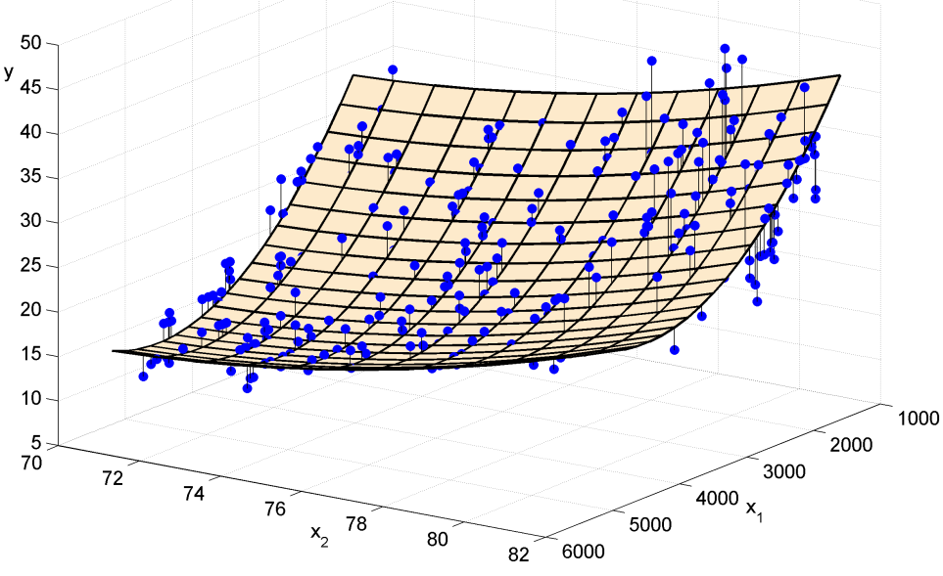

Figure 1. An example of the figure

Font size in the table equals to 11 pt. An example of table title is as follows:.

Table 1. Title of the table

|  |  |  |  |  |
| --- | --- | --- | --- | --- |
| Text |  |  |  |  |
|  |  |  |  |  |
|  |  |  |  |  |
|  |  |  |  |  |

A style of the software code is as follows:

for i=1:n

k(i)=mean(z(i:n));

b(i)=std(z(i:n));

end

Conclusions

Explain what kind of scientific result was obtained, indicate its title, essence, novelty, trustworthiness, and practical value. Where and how the new scientific result can be applied, what are the prospects for its development.

Acknowledgment

Please write the names of the funding organizations in full.

Authors’ contribution

The description of the authors' contribution is mandatory if the number of authors exceeds 3.

References

1. The reference list should include only works cited in the text and published or accepted for publication. Personal communications and unpublished works should only be mentioned in the text. Use APA style. At the end, include the DOI, if available. Examples are given below. It is recommended that you create a list of references using the Mendeley system.
2. Holland, J.H. (1992). *Adaptation in natural and artificial systems: an introductory analysis with applications to biology, control, and artificial intelligence*. MIT Press, 211 p.
3. Van Noorden, R. (2014). Online collaboration: Scientists and the social network. *Nature news*, *512* (7513), 126. DOI: 10.1038/512126a
4. Mora-Herrera, D.Y., Guillaume, S., Snoeck, D., & Zúñiga Escobar, O. (2020). Fuzzy Inference System as an Aggregation Operator-Application to the Design of a Soil Chemical Quality Index. In *International Conference on Information Processing and Management of Uncertainty in Knowledge-Based Systems*, 447-456. Springer, Cham. DOI: 10.1007/978-3-030-50143-3_35

Authors in Ukrainian: *If you are not fluent in Ukrainian, do not fill it out.*

Title of the article in Ukrainian: *If you are not fluent in Ukrainian, do not fill it out.*

Abstract in Ukrainian: *If you are not fluent in Ukrainian, do not fill it out.*

Keywords in Ukrainian: … *If you are not fluent in Ukrainian, do not fill it out.*

Select 1 or 2 of the most appropriate journal sections:

* Algorithms and data structures
* Information resources
* Decision-making models
* Meta-heuristic optimization
* Modeling and optimization of networked systems
* Safety and reliability of complex systems
* Human-computer interaction
* Internet of things systems
* Machine learning
* Knowledge engineering
* Natural language processing technologies.